[C Programming Logo](https://www.programiz.com/c-programming)

* [C++](https://www.programiz.com/cpp-programming)
* [PYTHON](https://www.programiz.com/python-programming)
* [R TUTORIAL](https://www.programiz.com/r-programming)
* [JAVA](https://www.programiz.com/java-programming)
* [KOTLIN](https://www.programiz.com/kotlin-programming)
* [home](https://www.programiz.com/)
* [TUTORIAL](https://www.programiz.com/c-programming)
* [EXAMPLES](https://www.programiz.com/c-programming/examples)
* [LIBRARY FUNCTIONS](https://www.programiz.com/c-programming/library-function)

[search](https://www.programiz.com/c-programming/c-file-examples)

C Programming File Examples

**In this article, you'll find several examples that will help you learn how to handle file input/output operations in C.**

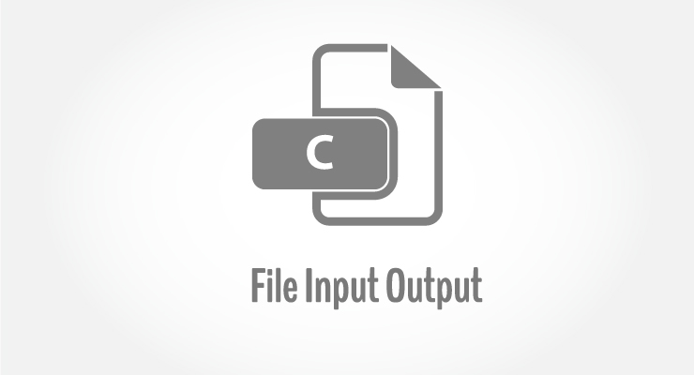

To understand all programs in this article, you should have the knowledge of following topics:

1. [Arrays](https://www.programiz.com/c-programming/c-arrays)
2. [Pointers](https://www.programiz.com/c-programming/c-pointers)
3. [Array and Pointer Relation](https://www.programiz.com/c-programming/c-pointers-arrays)
4. [Standard Library Functions](https://www.programiz.com/c-programming/library-function)
5. [File I/O](https://www.programiz.com/c-programming/c-file-input-output)

**C Programming File examples**

|  |
| --- |
| [Read name and marks of students and store it in file](https://www.programiz.com/c-programming/c-file-examples#read) |
| [Read name and marks of students and store it in file. If file already exists, add information to it.](https://www.programiz.com/c-programming/c-file-examples#append) |
| [Write members of arrays to a file using fwrite()](https://www.programiz.com/c-programming/c-file-examples#fwrite) |

**1. Write a C program to read name and marks of n number of students from user and store them in a file.**

#include <stdio.h>

int main()

{

char name[50];

int marks, i, num;

printf("Enter number of students: ");

scanf("%d", &num);

FILE *fptr;

fptr = (fopen("C:\\student.txt", "w"));

if(fptr == NULL)

{

printf("Error!");

exit(1);

}

for(i = 0; i < num; ++i)

{

printf("For student%d\nEnter name: ", i+1);

scanf("%s", name);

printf("Enter marks: ");

scanf("%d", &marks);

fprintf(fptr,"\nName: %s \nMarks=%d \n", name, marks);

}

fclose(fptr);

return 0;

}

**2. Write a C program to read name and marks of n number of students from user and store them in a file. If the file previously exits, add the information of n students.**

#include <stdio.h>

int main()

{

char name[50];

int marks, i, num;

printf("Enter number of students: ");

scanf("%d", &num);

FILE *fptr;

fptr = (fopen("C:\\student.txt", "a"));

if(fptr == NULL)

{

printf("Error!");

exit(1);

}

for(i = 0; i < num; ++i)

{

printf("For student%d\nEnter name: ", i+1);

scanf("%s", name);

printf("Enter marks: ");

scanf("%d", &marks);

fprintf(fptr,"\nName: %s \nMarks=%d \n", name, marks);

}

fclose(fptr);

return 0;

}

**3. Write a C program to write all the members of an array of structures to a file using fwrite(). Read the array from the file and display on the screen.**

#include <stdio.h>

struct student

{

char name[50];

int height;

};

int main(){

struct student stud1[5], stud2[5];

FILE *fptr;

int i;

fptr = fopen("file.txt","wb");

for(i = 0; i < 5; ++i)

{

fflush(stdin);

printf("Enter name: ");

gets(stud1[i].name);

printf("Enter height: ");

scanf("%d", &stud1[i].height);

}

fwrite(stud1, sizeof(stud1), 1, fptr);

fclose(fptr);

fptr = fopen("file.txt", "rb");

fread(stud2, sizeof(stud2), 1, fptr);

for(i = 0; i < 5; ++i)

{

printf("Name: %s\nHeight: %d", stud2[i].name, stud2[i].height);

}

fclose(fptr);

}